
Indian IT-BPO Industry: NASSCOM Analysis

I. Highlights

2007 was a year of continued growth for the technology and related services sector, with the worldwide spending aggregate estimated to reach nearly USD 1.7 trillion, a growth of 7.3 per cent over the previous year.

- Global market
  - Software and services continue to lead, accounting for over USD 1.2 trillion – over 71 per cent of the total spend in 2007
  - Hardware spends, at USD 478 billion, accounted for over 28 per cent of the worldwide technology spending aggregate in 2007
- Indian Market
  - Underlying the sustained growth were a range of economic, regulatory and demographic drivers – including a continued emphasis on trimming operational costs, dealing with increasing compliance and regulatory requirements, remaining price competitive, transforming into a global services oriented business model and addressing challenges of rising skill shortages, across several developed markets
  - Strong optimism of the industry to achieve its aspired target of USD 60 billion in exports by 2010

ending
II. Industry Performance

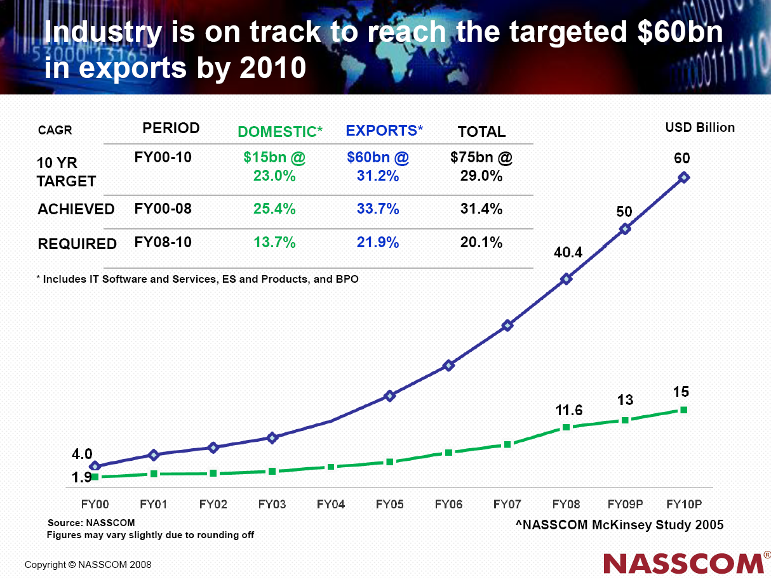

IT-BPO Industry - Sector-wise revenue break-up

USD billion | FY2007 | FY2008
IT Services | 23.5 | 31.0
-Exports | 18.0 | 23.1
-Domestic | 5.5 | 7.9
ITES-BPO | 9.5 | 12.5
-Exports | 8.4 | 10.9
-Domestic | 1.1 | 1.6
Engineering Services and R&D, Software Products | 6.5 | 8.6
-Exports | 4.9 | 6.4
-Domestic | 1.6 | 2.2
Total Software and Services Revenues  Of which, exports are | 39.5 | 52.0
Total Software and Services Revenues  Of which, exports are | 31.3 | 40.4
Hardware | 8.5 | 12.0
-Exports | 0.5 | 0.5
-Domestic | 8.0 | 11.5
Total IT Industry (including Hardware) | 48.0 | 64.0
Note: Figures may not add up due to rounding off.
Source: NASSCOM

III. Growth in Revenues

- Indian IT-BPO grew by 33 per cent in FY2008 to reach USD 64 billion in aggregate revenue, thus revalidating its strong fundamentals, despite concerns of a slowing US economy and supply constraints. Of this, the Software and Services segment accounted for USD 52 billion, growing by 28 per cent (currency-adjusted) over FY2007.
- Software and services exports (includes exports of IT services, BPO, Engineering Services and R&D and Software products) reached USD 40.4 billion, contributing nearly 63 per cent to the overall IT-BPO revenue aggregate.
- IT-BPO exports (including hardware exports) reached USD 40.9 billion in FY2008 as against USD 31.8 billion in FY2007, a growth of 28 per cent.
- While the US (61 per cent) and the UK (18 per cent) remained the largest IT-BPO export markets in FY2007, the industry footprint was steadily expanding to other geographies - with exports to Continental Europe in particular growing at a CAGR of more than 55 per cent over FY2004-2007.
- Domestic IT market (including hardware) reached 23.1 billion in FY2008 as against USD 16.2 billion in FY2007, a growth of 43 per cent. Hardware remained the largest segment of the domestic market with a growth rate of 44 per cent in FY2008. Software and services spending supported by increasing adoption, grew by over 41 per cent during the year.
- The industry’s vertical market exposure was well diversified across several mature and emerging sectors. Banking, Financial Services and Insurance (BFSI) remained the largest vertical market for Indian IT-BPO exports, followed by High-technology and Telecom. These sectors together accounted for nearly 60 per cent of the Indian IT-BPO exports in FY2007.
- Manufacturing, Retail, Media, Healthcare, Airlines and Transportation, and Utilities were the other key segments.
- Direct employment in Indian IT-BPO crossed the 2 million mark, an increase of about 389,000 professionals over FY2007; indirect job creation is estimated at about 8-9 million.
- IT services (incl. engineering services, R&D, Software products) exports, BPO exports and Domestic IT industry provides direct employment to 860,000, 700,000 and 450,000 professionals respectively.
- As a proportion of national GDP, the Indian technology sector revenue has grown from 1.2 per cent in FY1998 to an estimated 5.5 per cent in FY2008. Net value-added by this sector, to the economy, was estimated at 3.3-3.9 per cent for FY2008.
- Exports - Contributing 64 percent to the overall revenue aggregate, exports remain the mainstay of the Indian IT-BPO growth story. Software and services exports, accounting for over 98 per cent of the total exports, are crossed USD 40.4 billion and directly employs nearly over 2 million professionals, in FY2008 – a commendable achievement over just about two decades
- Exports by service segment
  - Broad-based growth, across all the segments of IT services, BPO, product development and engineering services, is reinforcing India’s leadership as the key sourcing location for a wide range of technology related services. Increasing traction in RIM, application management Widening service portfolios
  - IT services (excluding BPO, product development and engineering services), contributing 28.2 per cent of the total exports, remains the dominant segment and clocked USD 23.1 billion.
  - BPO services exports up by 30% (USD) accounting for over 1/4th of the export aggregate, is the fastest growing segment across software and services exports driven by scale as well as scope. Service portfolio strengthened by vertical specialization and global delivery capabilities. M&A continues to significantly complement organic growth
  - Complementing the strong growth in IT services and BPO exports is the continued growth across product development and engineering services, which also reflects India’s increasing role in global technology IP creation. Export revenues from these relatively high-value-added services such as engineering and R&D, offshore product development and made-in-India software products grew at 28.9 per cent, and clocked USD 6.4 billion in FY2007-8.
  - Domestic market grew at 26% in INR terms and clocked USD 11.6. Billion in FY2007-8.

Global Markets

While the US and the UK remain the largest export markets (accounting for about 61 per cent and 18 per cent respectively, in FY2007), the industry footprint is steadily expanding

Market | FY04 | FY05 | FY06 | FY07
Americas | 69.40% | 68.30% | 67.18% | 61.40%
Europe | 22.60% | 23.10% | 25.13% | 30.10%  (UK and Continental Europe)
Rest of the World | 8.00% | 8.60% | 7.69% | 8.50%  (APAC + ROW)

Growth Verticals

BFSI, Telecom and Hi-Tech continue to account for approximately 60% of the market. Other verticals are also growing rapidly

Manufacturing
15%
Hi
-
tech
/
Telecom
19.1%
BFSI
40.4%

Construction and Utilities
3.5%

Healthcare
2.5%

Media
,
Publishing and

Entertainment
3.3%

Other
4.7%

Retail
8%

Airlines and transportation
3.4%
FY07 Vertical market exposure for industry exports
GY 08

IV. Knowledge Professionals employed in the Indian IT-BPO sector

 | 2000-1 | 2001-2 | 2002-3 | 2003-4 | 2004-5 | 2005-6 | 2006-7 | 2007-8
IT Exp. & Services Exports | 162,000 | 170,000 | 205,000 | 296,000 | 390,000 | 513,000 | 690,000 | 860,000
BPO Exports | 70,000 | 106,000 | 180,000 | 216,000 | 316,000 | 415,000 | 553,000 | 700,000
Domestic Market | 198,114 | 246,250 | 285,000 | 318,000 | 352,000 | 365,000 | 378,000 | 450,000
Total | 430,114 | 522,250 | 670,000 | 830,000 | 1,058,000 | 1,293,000, | 1,621,000 | 2,010,000
*Figures do not include employees in the hardware sector
Source: NASSCOM

V. Domestic Market Matures

Technology adoption in the domestic market also reported steady gains in FY 2008. This segment is expected to cross USD 23 billion in FY2008, reporting healthy growth across all key segments. Hardware remains the largest segment of the domestic market, and is expected to grow at 44 per cent in FY2008.

Domestic IT services spends are estimated to be growing at about 43 per cent in FY2008, and are showing strong signs of increasing sophistication as building enterprise IT infrastructures and applications, networking and communication become key priorities for India Inc.

Software and BPO spending growth in the domestic market is being supported by increasing adoption, and is expected to grow by over 37 per cent and 45 per cent, respectively.

VI. Going forward

Manufacturing
15%
Hi
-
tech
/
Telecom
19.1%
BFSI
40.4%

Construction and Utilities
3.5%

Healthcare
2.5%

Media
,
Publishing and

Entertainment
3.3%

Other
4.7%

Retail
8%

Airlines and transportation
3.4%
FY07 Vertical market exposure for industry exports
GY 08

- From a fundamentals viewpoint, the drivers for global sourcing are likely to remain strong in the near future
- Most environmental factors affecting global sourcing also look favourable despite concerns of a possible economic slowdown
- While the short-term US outlook is muted, global tech spending forecasts remain strong, supported by momentum in EMEA and APAC, and an expected resurgence in the US
- Nature of short-term cutbacks in US technology spends are unlikely to impact global sourcing negatively; in fact could even boost its growth
- Worldwide adoption of outsourcing, another key influencing factor, is also expected to grow rapidly over the next five years
- Overall thus, global sourcing of services seems well-placed to continue expanding its share of worldwide IT-BPO spending
- Sufficient demand, strong fundamentals and a favourable environment support a positive outlook for Indian IT-BPO exports
- Further, strong imperatives for increasing technology adoption in India represent significant potential for growth in the domestic market
- Indian IT-BPO is on track to reach USD 60 billion in exports and USD 73-75 billion in overall software and services revenues by 2010. FY09 software and services growth forecast 20-23% (USD)
- However, the long-term opportunity is much larger and could yield significant pay-offs not just for the industry but India as a whole
- India is well-positioned to capitalise on this opportunity; key stakeholders need to continue working in a focussed and coordinated manner
- Increased focus on cost and productivity in the recessionary environment is likely to fuel demand for offshore services
- Focus areas for NASSCOM in FY08-09 ‘Six Point Agenda’
  - Creativity- Tap the opportunity to add new revenues through product, process and business model innovation
  - Community - Build communities of best practices that enable professionals to interact across organisation and geography barriers
  - Collaboration - Continue the collaboration between firms and with industry associations in key markets and collaboration countries
  - Adoption of Green IT -Encourage environmental responsibility aided by the search for greater productivity and competitiveness, reducing waste and increasing efficiency
  - Societal development and inclusivity- Strengthen rural India as a complementary force to Urban India’s capabilities in the Industry. Gender inclusivity and inclusion of differently-abled workforce in the IT-BPO sectors
  - Education and skill building - Continue to undertake focussed efforts towards developing an employable workforce through scaling of various ongoing initiatives

